Week 4 Day 2 Assignment
Fine Tune the model
and use it in web-extension and verify the result generated based on the training.
Fine tuning extracted folder

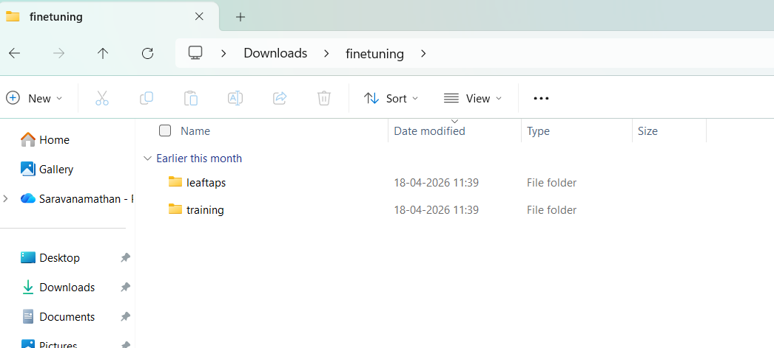

The fine tune model is imported in VS code and input / Output paths updated
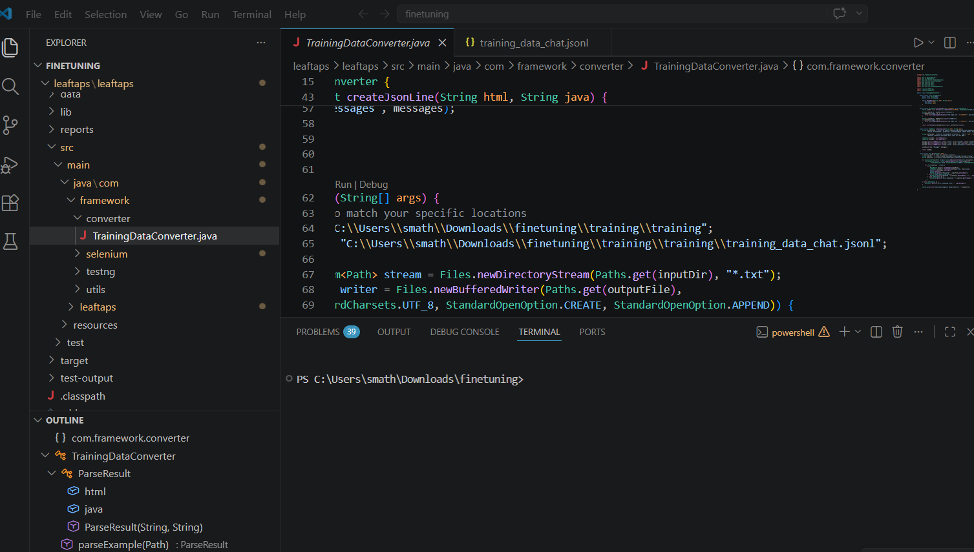

Created Json file
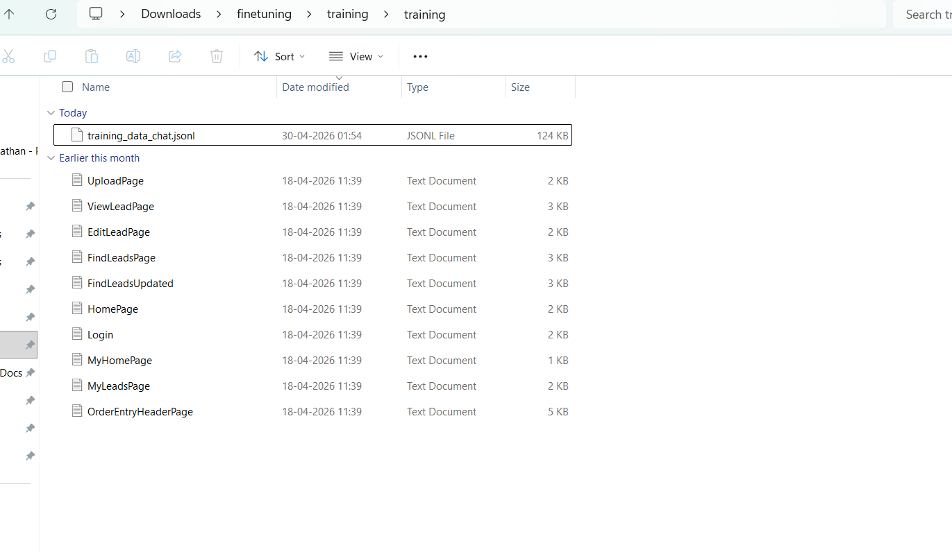
Fine tune model created in api.testleaf.com

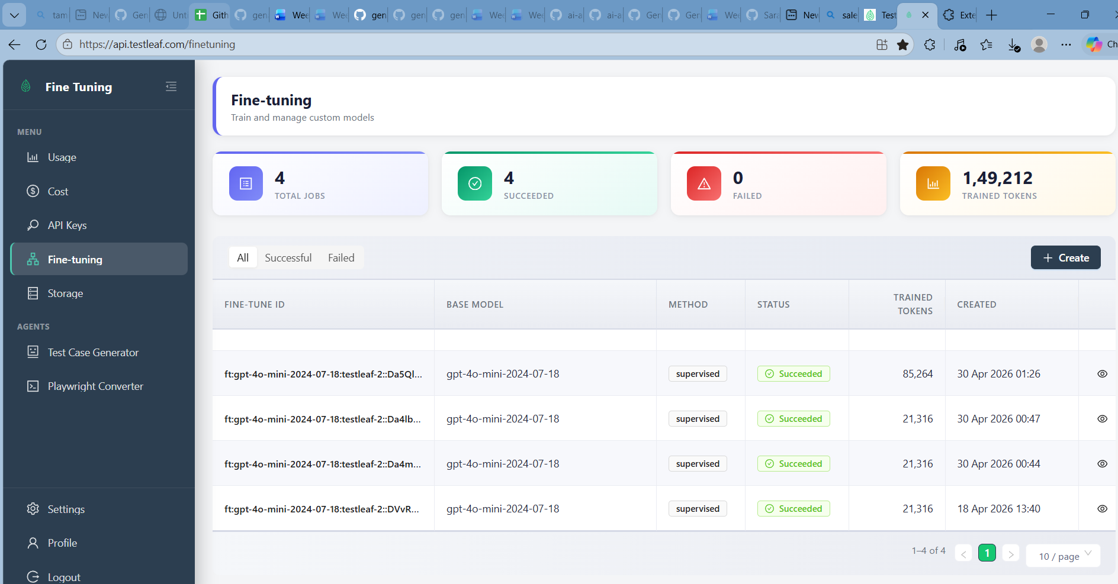
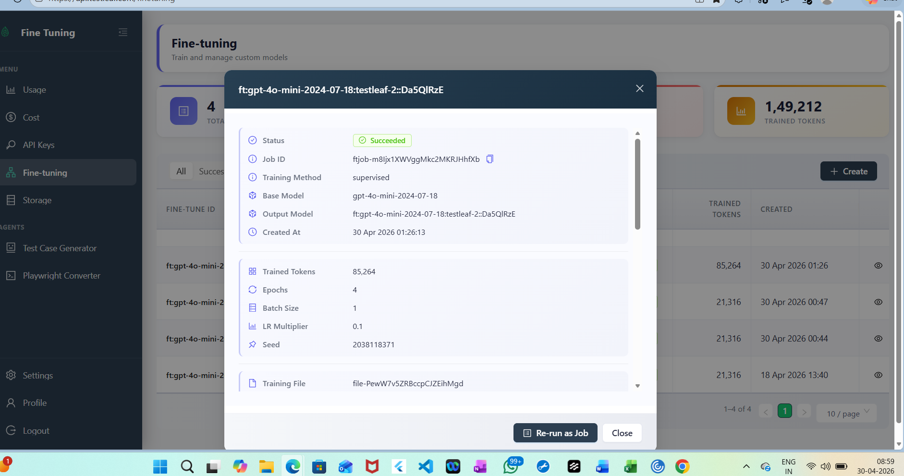

Updated the popu.js in vs code for Ai extension
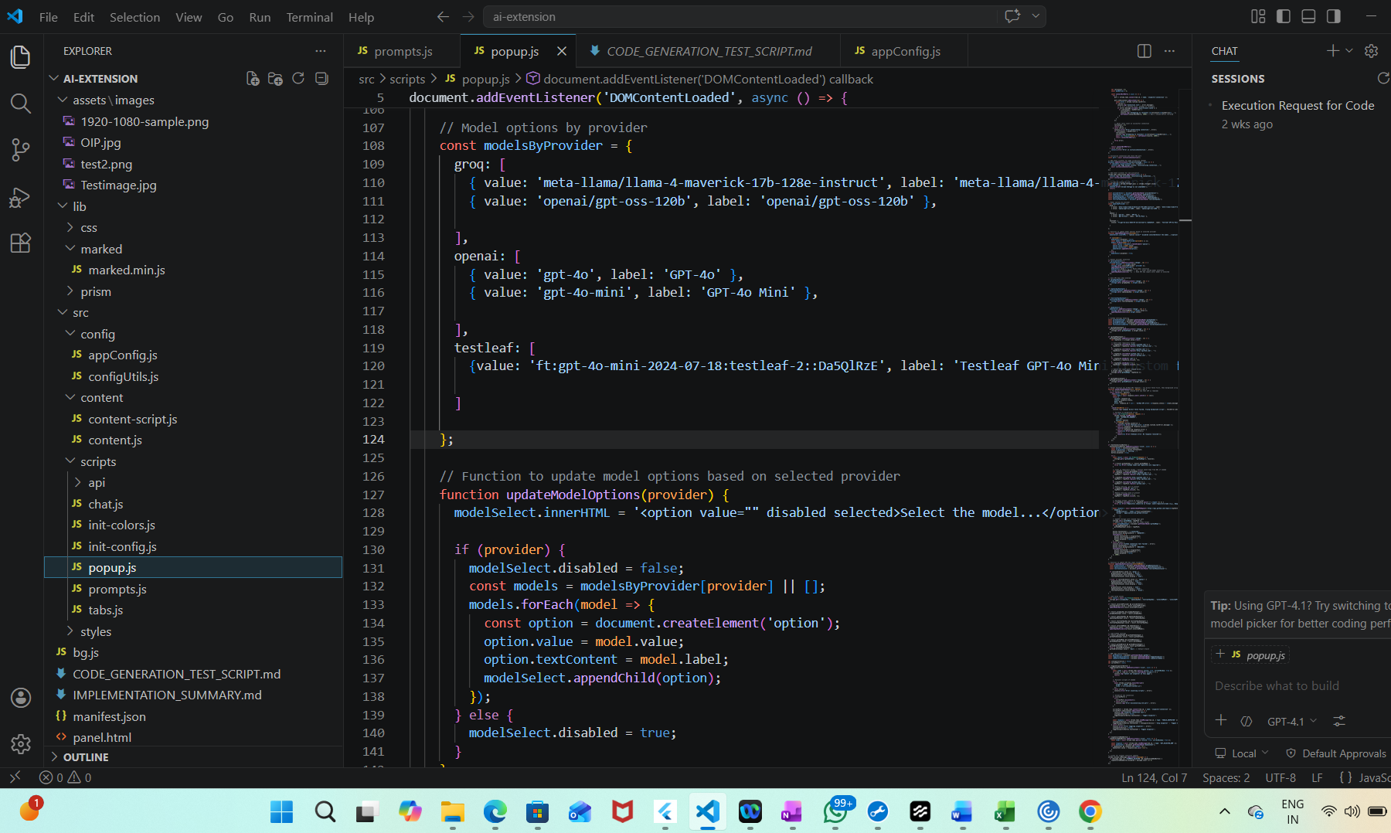
Refreshed the edge extension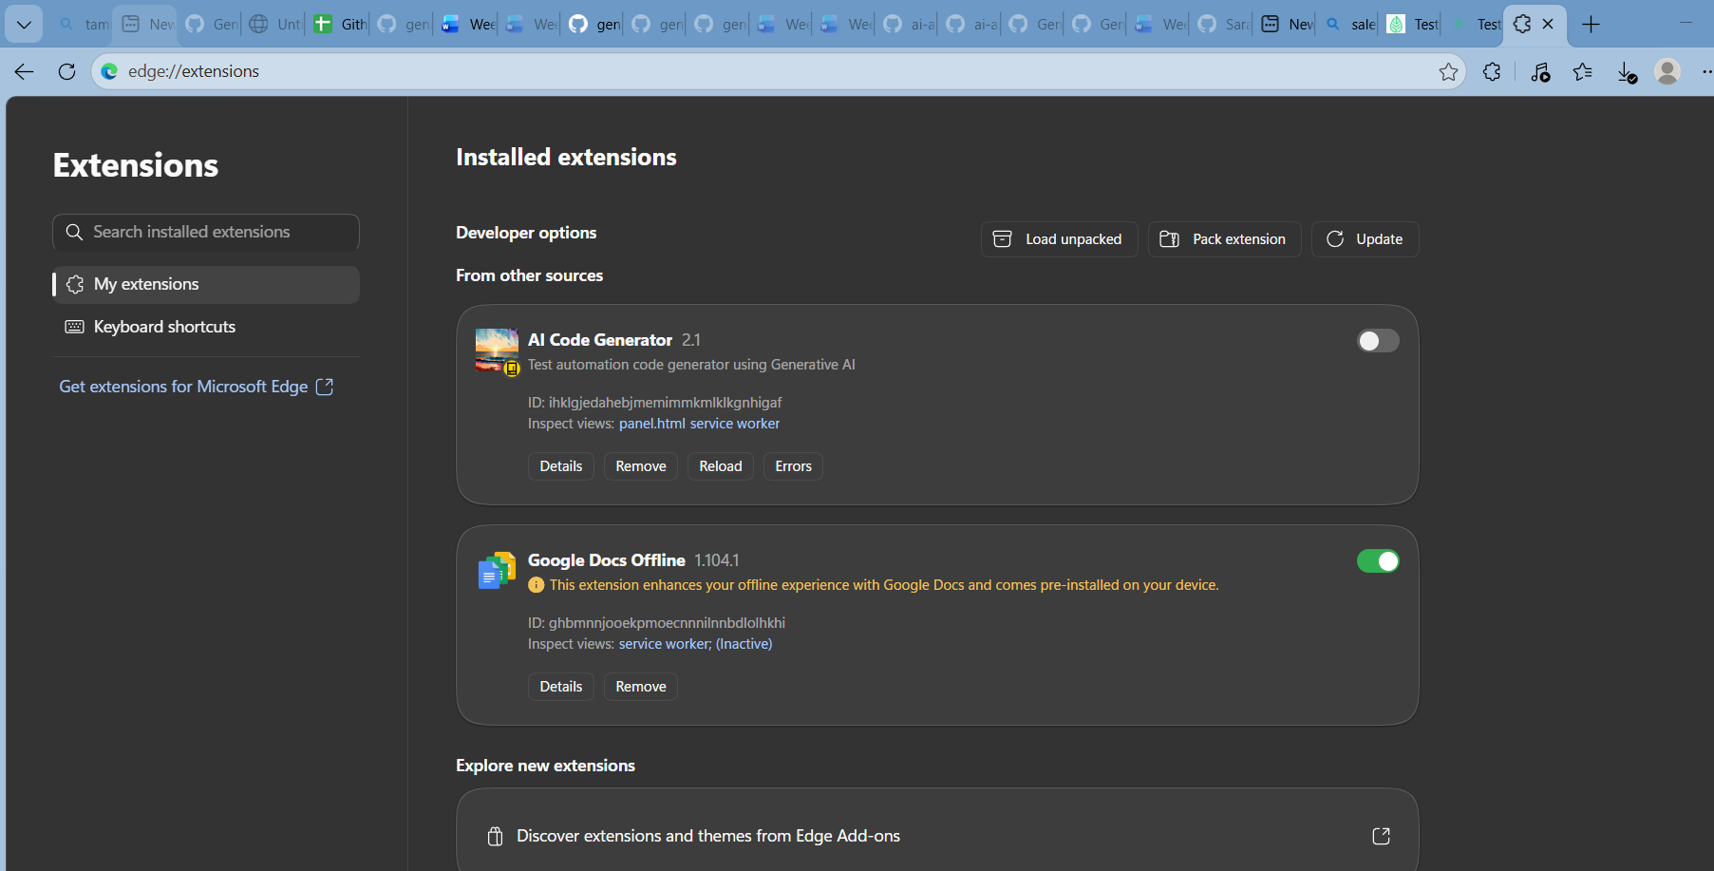
Created API key in api.testleaf
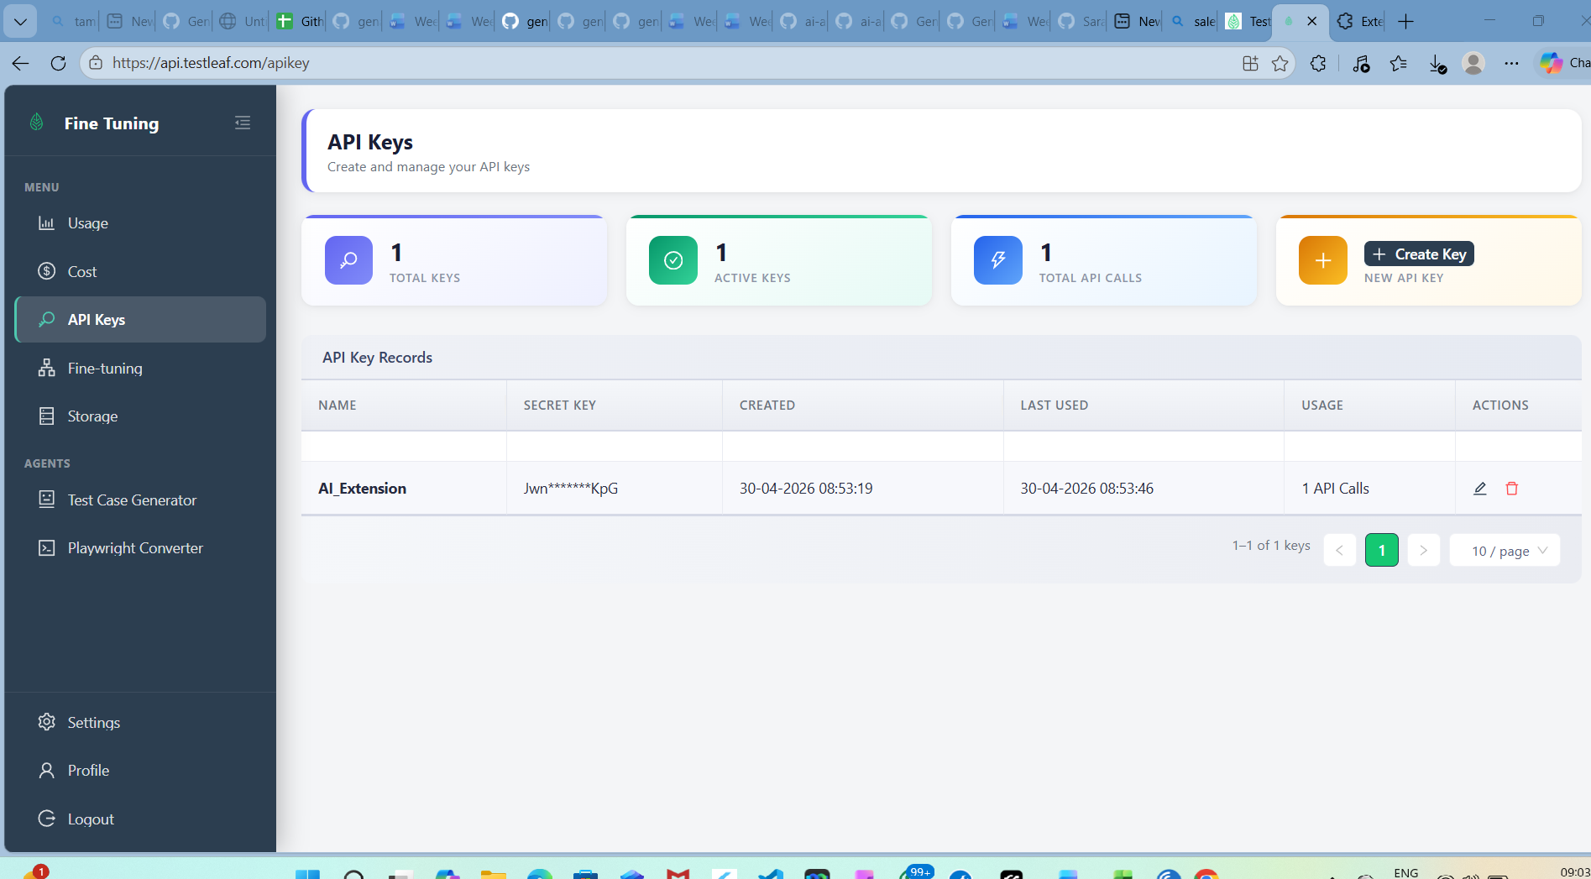

Updated the extension settings after refreshing it
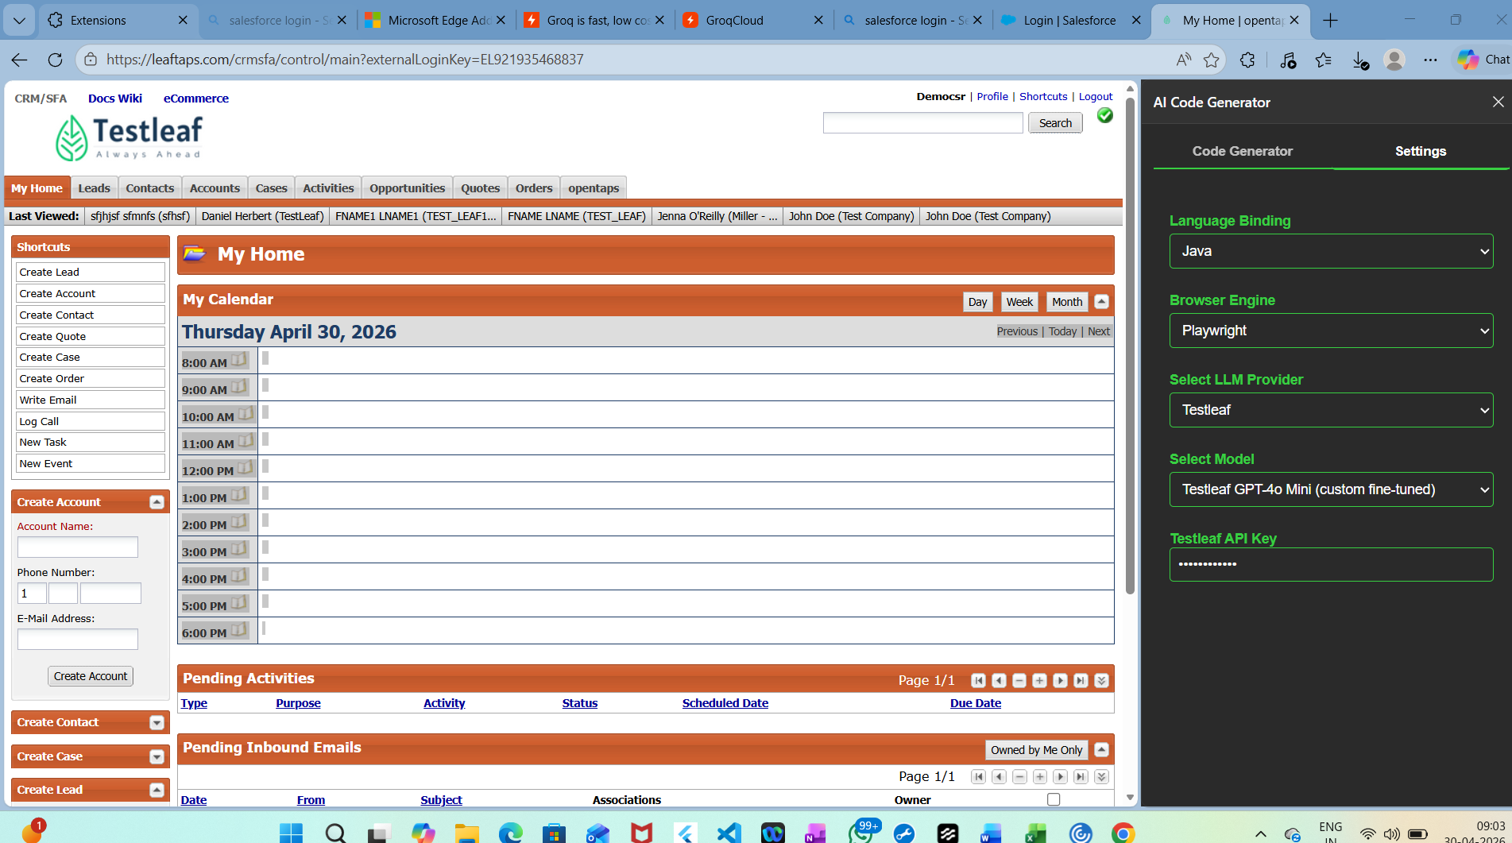

Code Generator output
